HD 215456

HD 215456 is a 1.264 M☉, G0.5 V star1. The CH survey reported a GP (HD 215456b) with a period of 192 days, a minimum mass of 0.1 MJup and an eccentricity of 0.13, as well as a GP (HD 215456c) signal with a period of 2268 days, a minimum mass of 0.24 MJup and an eccentricity of 0.17.

In the present study, 267 RV HARPS measurements obtained between 2003 and 2017 were considered. DPASS and MCMC (1000 walkers and 400000 iterations) were used to fit the present RV data. The properties of planets b and c are close to those reported in the CH survey.

The fits are shown in Fig 1, and the corner plot in Fig 2, and the results summarized in Table 1.

Conclusion: The properties found in the CH survey for both planets are confirmed.

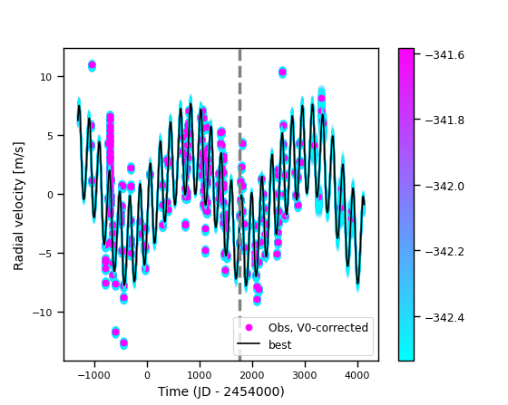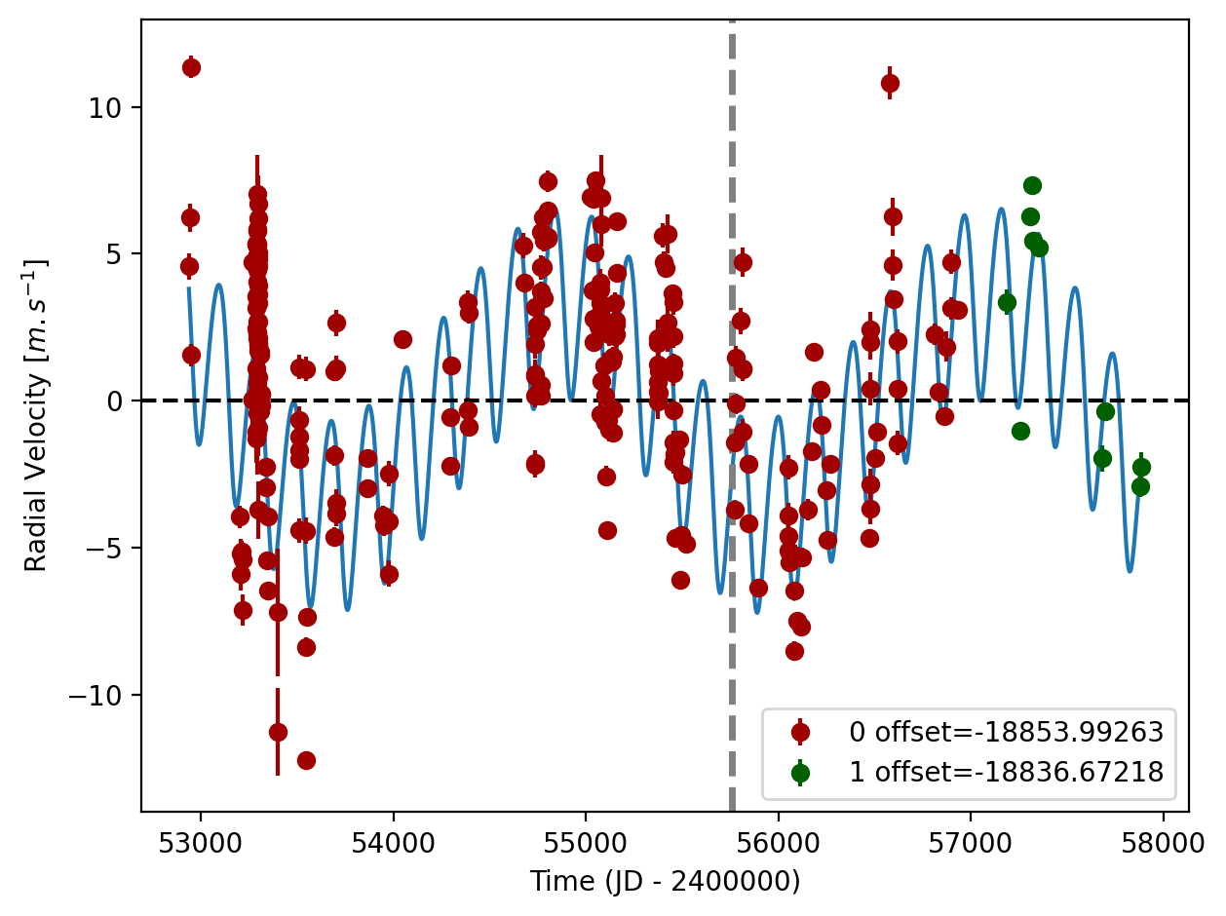

Figure 1: Left: fit of the HD 215456 RV with DPASS. Red - H03, green - H15. The blue curve shows the best fit. Right: fit of the HD 215456 RV using MCMC. The black curve shows the best fit. The colorbar corresponds to the log-likelihood of the fits. The gray dotted line indicates the end of the CH survey.

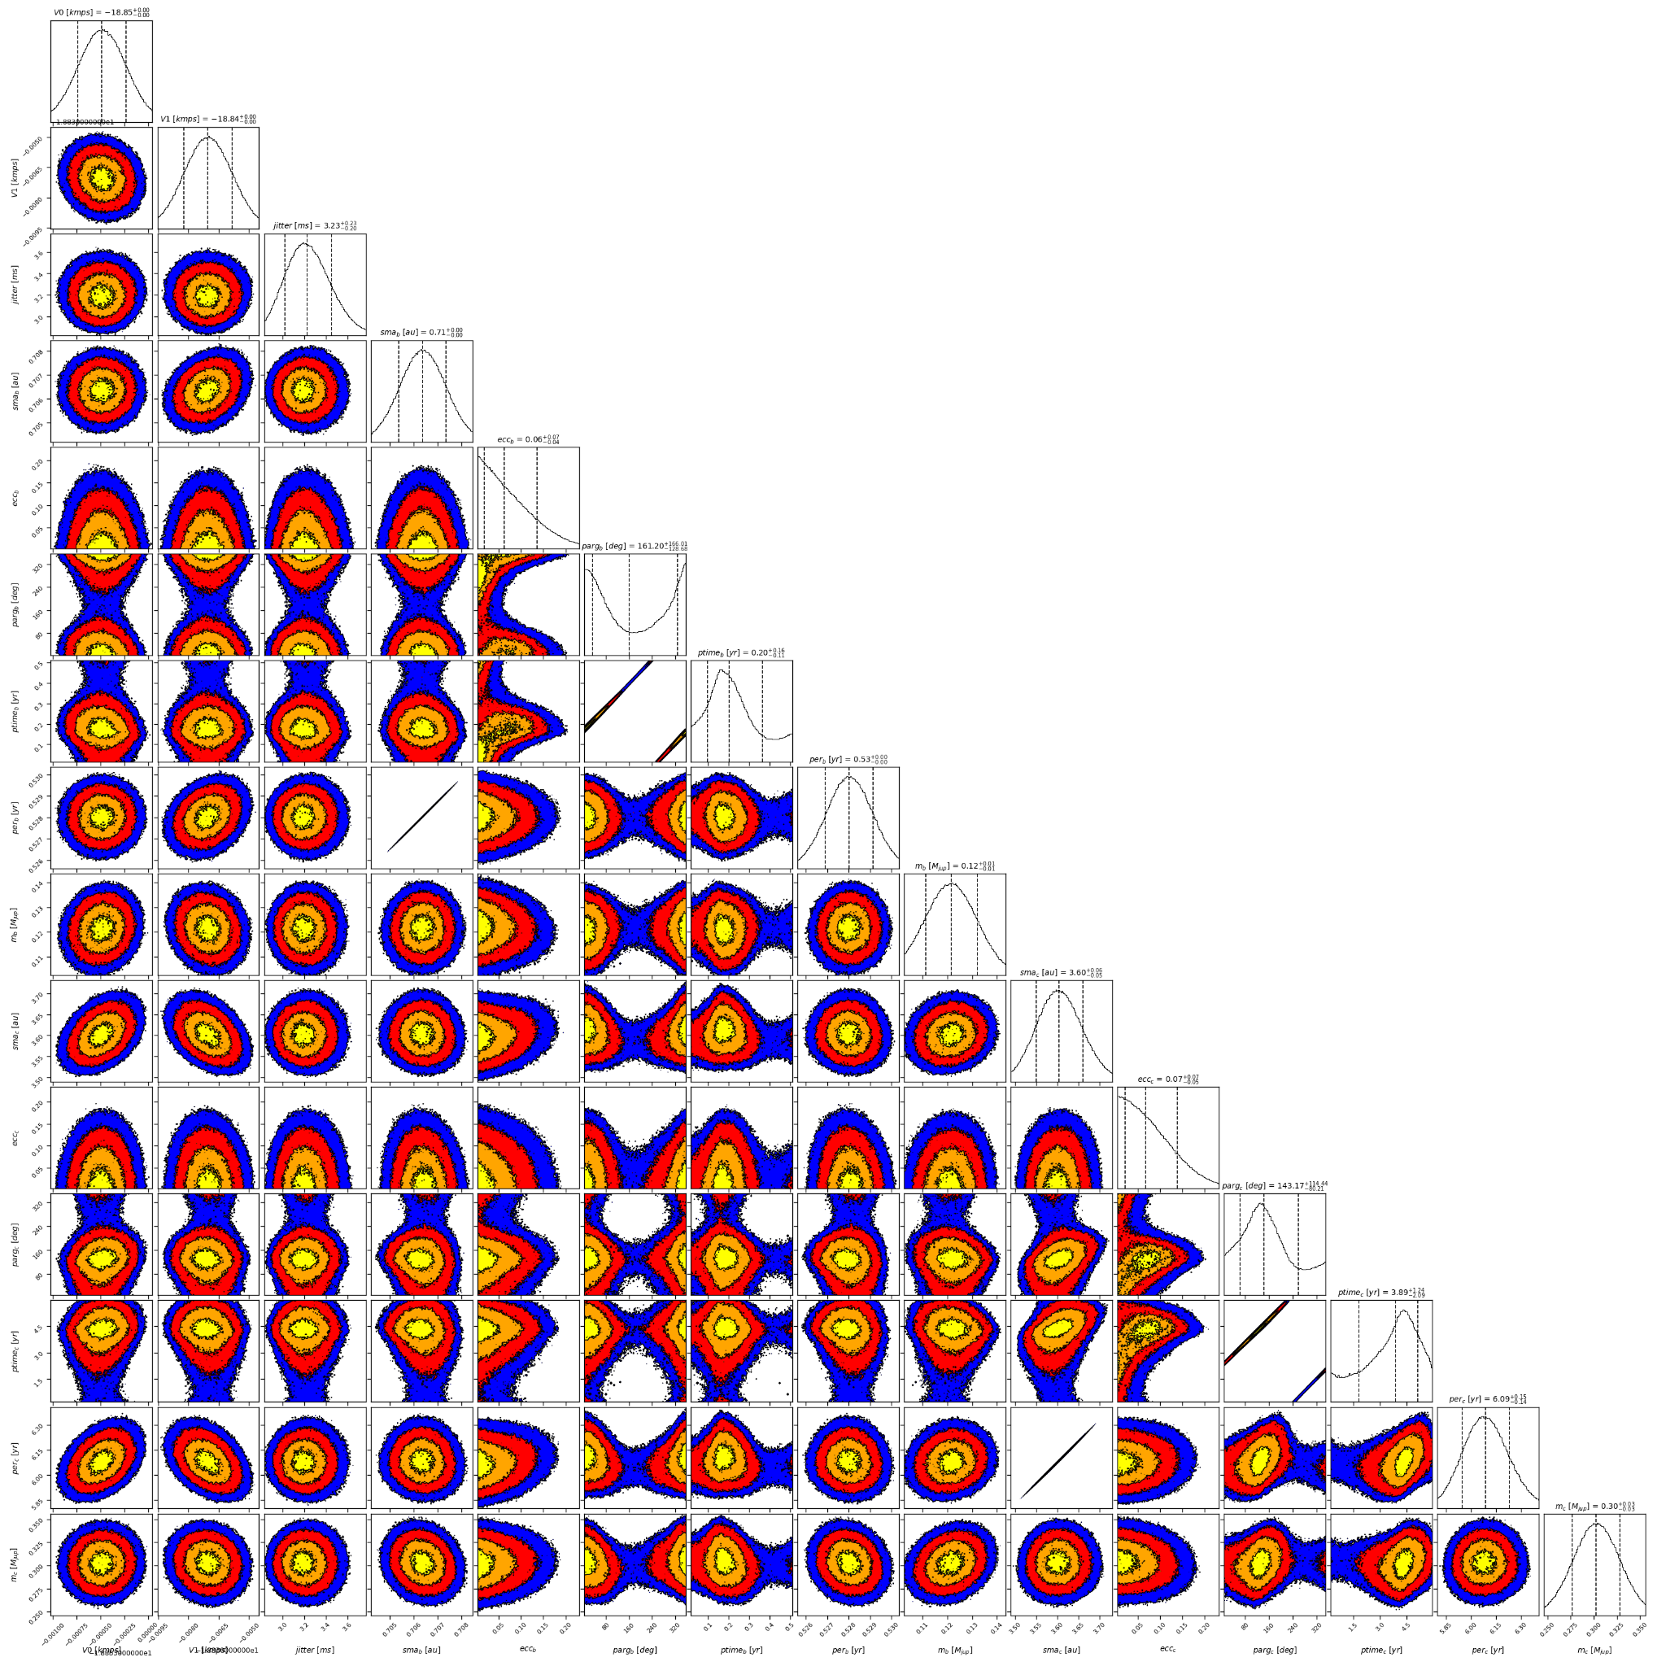

Figure 2: Corner plot of posteriors for the two-planets model MCMC fit of HD215456 RV data.

| Parameter | Priors | | Posteriors | | CH survey |
| --- | --- | --- | --- | --- | --- |
|  | DPASS | MCMC | DPASS | MCMC |  |
| *a* (au) | b: [0,1]  c: [0,80] | b: [0.01,1]  c: [2,10] | b = 0.7  c = 3.6 | b = 0.706 ± 0.001  c = | b = 0.7  c = 3.7 |
| Msin(i) (MJup) | b: [0,1]  c: [0:100] | b: [0.01,1]  c: [0.1,5] | b = 0.12  c = 0.3 | b = 0.12 ± 0.01  c = | b = 0.1  c = 0.24 |
| Eccentricity | b: [0,0.5]  c: [0,0.95] | b: [0,0.5]  c: [0,0.9] | b = 0.1  c = 0.09 | b < 0.14  c < 0.14 | b = 0.13  c = 0.17 |
| Instrumentals offsets (km/s) | [-100,100] | [-20,-18] | H03: -18.854  H15: -18.837 | H03: -18.854 ± 0.001  H15: -18.837 ± 0.001 |  |
| Stellar jitter (m/s) | [0,40] | [0,40] | 3.1 |  |  |
| Argument of periastron (°) | b: [0,360]  c: [0,360] | b: [0,360]  c: [0,360] | b = 93  c = 122 | b = 33 – 327  c = 63 – 258 |  |
| Phase | b: [0,1]  c: [0,1] | b: [0,1]  c: [0,1] | b = 0.66  c = 0.06 | b = 0.18 – 0.69  c = 0.30 – 0.84 |  |

Table 1: HD215456. Summary of priors and posteriors obtained with DPASS and MCMC, compared to the properties reported by the CH Survey.

References

1. Kervella, P. et al. Stellar and substellar companions of nearby stars from Gaia DR2. Binarity from proper motion anomaly. *Astron. Astrophys.* 623, A72 (2019).